## Introduction

Delta Modulation (DM) emerges as a cost-effective alternative to Pulse Code Modulation (PCM) in digital pulse communication. PCM, while accurate, involves complex encoding and decoding processes, leading to high implementation costs in hardware and computational resources. DM offers a more efficient solution by oversampling the modulating signal, simplifying the encoding process, and reducing hardware complexity.

In PCM, various operations such as encoding, decoding, and quantizing contribute to the formation of a complex circuit, making practical implementation costly. In contrast, DM streamlines these processes, resulting in a more economical and efficient digital communication technique.

# Basic Principles of Delta Modulation

DM leverages oversampling, where the sampling frequency (FS) exceeds twice the frequency of the modulating signal. This oversampling ensures that adjacent samples of the modulating signal are highly correlated, simplifying subsequent quantization.

Sampling frequency ($Fs$) determines the number of samples taken per unit time, while the sampling rate ($1/Ts$) indicates the time interval between consecutive samples. In Delta modulation, oversampling is a critical technique. Oversampling involves setting the sampling frequency $Fs$ far greater than twice the frequency of the incoming signal ($Fm$). Mathematically, this relationship can be expressed as:

$$Fs≫2Fm$$

By oversampling the $Fm$ the correlation between adjacent samples is enhanced. This increased correlation allows for the application of simpler quantization techniques, as the signal exhibits reduced variation from one sample to the next. Correlation between samples implies that neighbouring samples at $2Ts, 3Ts,$ and subsequent intervals are highly related, indicating minimal rapid changes in the signal over time. This characteristic is advantageous in Delta modulation, where the goal is to generate coded signals using straightforward quantization methods.

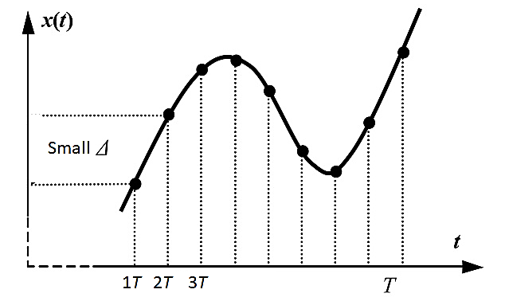

Figure 1: Correlation between Adjacent Samples**

Delta modulation involves the conversion of the oversampled modulating signal $m\left(t\right)$ into a staircase approximation, denoted by $m_{Q}\left(t\right)$ which simplifies the quantization process. This staircase approximation consists of two quantized levels: plus Delta and minus Delta, corresponding to positive and negative differences, respectively, between consecutive samples of the modulating signal. The quantization process entails comparing the quantized approximation, denoted as $m_{Q}\left(t\right)$ with the modulating signal, $m\left(t\right)$ If the quantized approximation, MQ(T), is less than the modulating signal, MT, the level is increased by Delta. Conversely, if the quantized approximation exceeds the modulating signal, the level is decreased by Delta. The same is shown in figure below

$$m_{Q}\left(t\right) = \text{sgn}\left(m\left(t\right)\right) ⋅ Δ$$

Where the value of $Δ$ is determined as follow

$$Value of Δ =\left\{\begin{aligned} m_{Q}\left(t\right) <m\left(t\right) ↑ Δ \\ m_{Q}\left(t\right) >m\left(t\right) ↓ Δ \end{aligned}\right.$$

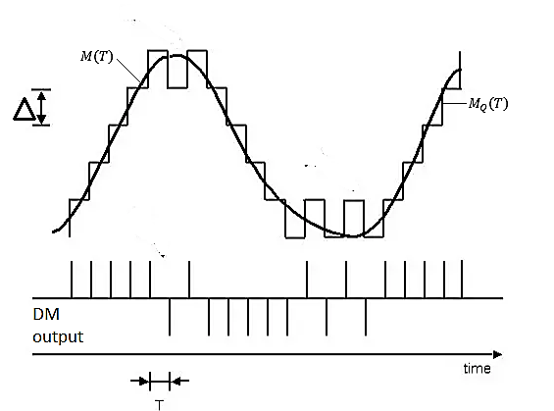

# Discrete-Time Relations

DM operation relies on three key discrete-time relations:

## 1. Error Signal:

The error signal represents the difference between the current sample of the modulating signal and the latest approximation of sampled version $m\left[nt_{s}\right]$

$$e\left[nt_{s}\right]=m\left[nt_{s}\right]-m_{Q}\left[nt_{s}-t_{s}\right]$$

## 2. Quantized Error Signal:

- The quantized error signal is obtained by quantizing the error signal using a sgn function, resulting in two levels, Delta and -Delta.

$$(e_{Q}\left[ntS\right]=Δ⋅\text{sgn}\left(e\left[nts\right]\right))$$

## 3. Quantized Modulating Signal:

The quantized modulating signal is generated by accumulating the quantized error signal, ensuring accurate tracking of the modulating signal.

$$(m_{Q}\left[nt_{S}\right]=m_{Q}\left[nt_{S}–T_{S}\right]+e_{Q}\left[nt_{S}\right])$$

-

# Sampling Frequency and Sampling Rate

Sampling frequency (FS) determines the rate at which samples are taken, while the sampling rate (1/TS) governs the rate of information transmission in DM systems. Higher sampling frequencies allow for more accurate representation of the modulating signal, enhancing the fidelity of the transmitted signal. The sampling rate is inversely proportional to the time interval between samples, influencing the overall performance and efficiency of DM systems.

# Transmitter Block Diagram

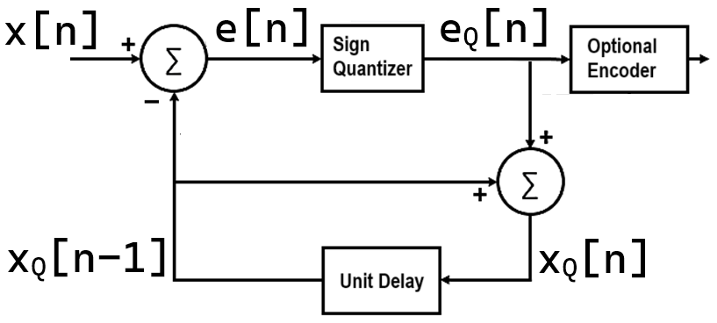

The transmitter comprises several key components, including a comparator, quantizer, and accumulator. The comparator compares the input sample of the modulating signal with the latest approximation, generating an error signal based on the difference between the two. The quantizer quantizes the error signal, producing a quantized version with two levels, Delta and -Delta. The accumulator accumulates the quantized error signal, updating the staircase approximation to track the modulating signal accurately over time

The accumulator plays a crucial role in DM, ensuring the accurate tracking of the modulating signal over time. - It incrementally adjusts the staircase approximation based on the quantized error signal, effectively following the variations in the modulating signal. By continuously updating the staircase approximation, the accumulator maintains synchronization with the modulating signal, facilitating reliable signal transmission.

Assuming that accumulator process starts at zero

$$(m_{Q}\left[nt_{S}\right]=m_{Q}\left[nt_{S}–t_{S}\right]+e_{Q}\left[nt_{S}\right])$$

Where

$e_{Q}\left[nt_{S}\right])$ = $Δ.\text{sgn}\text{( }e\left[nt_{S}\right] )⋅$

Plugging the value of $Δ\text{sgn}E\left[nT_{S}\right] to the above equation$

$$(m_{Q}\left[nt_{S}\right]=m_{Q}\left[nt_{S}–t_{S}\right]+Δ . \text{sgn}\text{(}m\left[nt_{s}\right]-m_{Q}\left[nt_{s}-t_{s}\right])$$

From the analysis of above equation, we can conclude

|  |
| --- |
| If e $\left[nt_{S}\right] = Postivie$ $m_{Q}\left[nt_{s}-t_{s}\right])<$ m $\left[nt_{s}\right]$ Increment delta in positive direction |
| If e $\left[nt_{S}\right] =Neagtive$ $m_{Q}\left[nt_{s}-{Tt}_{s}\right])>$ m $\left[nt_{s}\right]$ Decrement delta in positive direction |

# Encoder and Transmission

Encoding and transmission processes are essential aspects of DM communication, ensuring the efficient and reliable transfer of data. The quantized output from the accumulator is encoded into a bit sequence for transmission over a communication channel. Efficient encoding techniques minimize data loss and distortion, optimizing the utilization of available bandwidth for data transmission.

The receiver on other hand comprises components such as a decoder, accumulator, and low-pass filter, essential for signal reception and recovery. The decoder decodes the received data sequence, reconstructing the quantized error signal for further processing.The accumulator generates the staircase approximation, which is then filtered using a low-pass filter to recover the original modulating signal from the transmitted data.

# Decoding and Recovery

Decoding involves converting the received data sequence into quantized error signals, enabling the reconstruction of the staircase approximation. The recovered staircase approximation, when filtered using a low-pass filter, yields the original modulating signal with high fidelity. - Through decoding and recovery processes, DM systems ensure the accurate transmission and faithful reproduction of the modulating signal.

**Task 1:** Generate a signal comprising two tones as described below:

$$x\left(t\right)=A_{1}\sin{(2πf_{1}t)}+A_{3}\sin{(2πf_{3}t)}$$

Where $A_{1}=1, A_{3}=1, f_{1}=1,$ and $f_{3}=3$.

The signal is to be regularly sampled with frequency $f_{S}=Kf_{3},$ where $K=20/3$ and $f_{3}=3$ giving $f_{S}=20$ Hertz. The sampled signal $x_{S}\left(t\right)$ is quantized to a real number that may be represented in $B$ bits using the MATLAB function **quantize_v**.   
Use $B=8$, and obtain a quantized signal $x_{Q}\left(t\right)=$ **quantize_v $(x_{S}\left(t\right),B)$**. Show plot of one cycle of $x\left(t\right)$ and $x_{Q}\left(t\right)$. Your plot should look like as shown below:

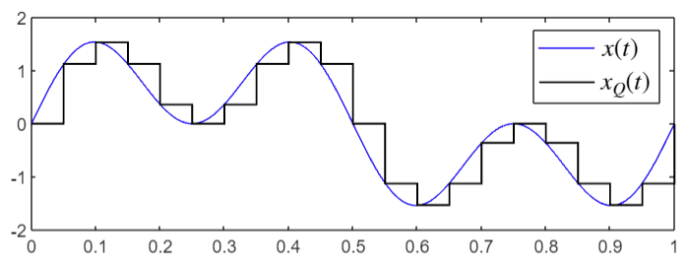

Note: For this task, you do not necessarily need to add extra repeated samples for each quantized level to make it look like flat topped; you may simply use MATLAB **stairs** command to plot $x_{Q}\left(t\right)$.

**Task 2:** Obtained the Fourier transform of the quantized signal $x_{Q}\left(t\right).$ Here you need to repeat each quantized level $L$ times so that it look like a flat-topped holded pulse. Let $x_{Q}\left(t\right)$ be denoted as **xQt** in MATLAB; the following piece of code may help you get this task done in an efficient way:

**xQt** **= repmat(xQt, L, 1); xQt** **= xQt(:);**

Consider $L = 40$.

Since, each quantized holded level is now represented as $L$ number of samples (repitition/oversampling), it means the sampling frequency is scaled to $Lf_{S}$ in the computer simulation.

Obtain the **fft** of **xQt**, multiply it with computer simulation sampling time, where the computer simulation sampling time is now equal to $1/( Lf_{S})$. Explain in your report why this multiplication is required, weve discussed this in an earlier lab.

Plot the absolute value of FFT versus the frequency axis which goes from zero to $Lf_{S}$ Hertz containng exaclty same number of elements as that in **xQt**. This is done as follows:

**faxis = linspace(0, fs*L, length(xQt));**

The **fft** plot using **plot** should be obtained as shown below:

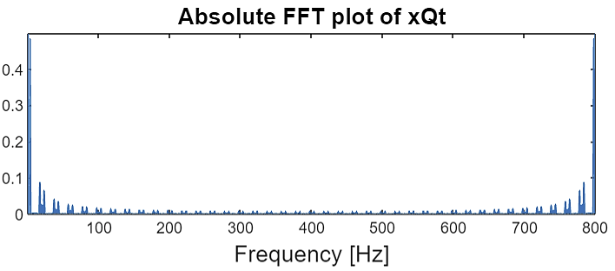

Provide a zoom-in **stem** plot as shown below: use appropriate **xlim** and **ylim**.

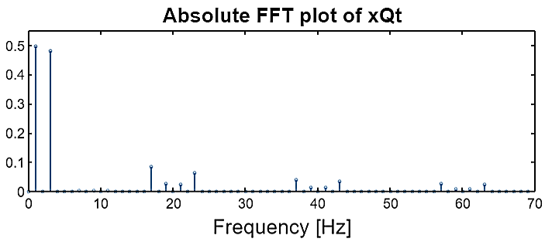

Explain this plot in your report. Explain why the amplitudes of sinusoids at $f_{1}=1$ Hz and $f_{3}=3$ Hz are appearing as halved values; explain why the amplitude of 3-Hertz tone is even smaller than 1-Hertz tone while in the actual signal $x(t)$, both tones have unit amplitudes. Also explain the cluster of tones around 20, 40, and 60 Hertz. Justify the values of the tones amplitudes using the sinc function that appears in the transfer function of zero-order-hold system.

Here, we implement $ΔΣ$ modulator. As we know that in this modulator the errors are quantized instead of actual samples.

In $ΔΣ$ modulator, note that:

1. First, the sampling signal is **over-sampled**. So, in comparison to the ordinary sampling and $B$-bit quantization as you did in Task 1 where the sampling frequency is $f_{S}=Kf_{3}=20$, here, you oversample $x(t)$ by an increased factor $K_{2}$. So the sampling frequency in $ΔΣ$ modulator is $K_{2}f_{s}.$
2. In $ΔΣ$ modulator, we do not quantize the signal samples. Rather, we quantize the error between the the present discrete-time sample x[n] of the sampling signal $x(t)$ at index n and the ***predicted*** quantized sample xQ[n-1] at time index n-1. So, an error signal at index n is obtained as

e[n] = x[n] - xQ[n-1]

1. The $ΔΣ$ modulator then quantizes the error into one of the two possible values, that is $+Δ$ or $-Δ$. If e[n] is the present error, its quantized version eQ[n] is obtained as:

eQ[n]=**Δ**\*sign(e[n])

eQ[n]=+**Δ** when e[n]>0, and eQ[n]=-**Δ** when e[n]<0.

1. As a result, the $ΔΣ$ modulator has to transmit one of the two possible quantized alphabets $+Δ$ and $-Δ$. If we also talk about the encoder, then the encoder converts the alphabet $+Δ$ into bit-**1**, and $-Δ$ into bit-**0**. In this lab, however, we may skip the encoder and discuss only the transmission of quantized alphabets $±Δ$. So, the task at the receiver would be to reconstruct the analog signal from the received $±Δ$ alphabets.
2. Since, our goal is to compare $ΔΣ$ modulator with the ordinary sampling and $B$-bit quantization scheme; a suitable value of $K_{2}$ is $K_{2}=B.$ The reason is that instead of transmitting $B$ number of binary bits (to represent a quantized sample), the $ΔΣ$ modulator oversamples the sampling signal using the sampling frequency $Bf_{s}$, and transmits only one bit (or one quantized alphabet) at any given instant.
3. Given the ***predicted*** quantized sample xQ[n-1] at discrete-time n-1, and the quantized error eQ[n], the ***predicted*** quantized sample xQ[n] at time n is obtained as follows:

xQ[n] = eQ[n] + xQ[n-1]

1. The whole scenario may be described by a block diagram as follows:



**Task 3:** Using nearly the same parameters and signals as in Task 1 and Task 2, you are required here to simulate $ΔΣ$ modulator.

1. Sample the signal $x\left(t\right)$ $$x\left(t\right)=A_{1}\sin{(2πf_{1}t)}+A_{3}\sin{(2πf_{3}t)}$$

where $A_{1}=1, A_{3}=1, f_{1}=1,$ and $f_{3}=3$, with   
sampling frequency $K_{2}f_{s}=Bf_{s}=8*20=160$ Hertz, and obtain x[n].

1. The initial value of xQ[n-1] may be taken as zero.
2. The operation of $ΔΣ$ modulator is goverened by the following three equations:

e[n] = x[n] - xQ[n-1]

eQ[n] = Δ*sign(e[n])

xQ[n] = eQ[n] + xQ[n-1]

1. The value of Δ to obtain eQ[n] is a challenging issue. An appropriate value of Δ must be chosen carefully. Its value usually depends on the amplitude of the highest frequency component in the sampling signal. Since the highest frequency component in the sampling signal is $A_{3}$.   
   Considering $B=8$ bits, $K_{2}f_{s}=160$ Hertz, a table is provided below for an appropriate value of Δ for some values of $A_{3}$:

|  |  |  |  |  |  |  |
| --- | --- | --- | --- | --- | --- | --- |
| $$A_{3}$$ | 0.25 | 0.5 | 0.75 | 1.00 | 1.25 | 1.50 |
| Δ | 0.0781 | 0.1602 | 0.1875 | 0.1914 | 0.2266 | 0.2422 |

1. For $A_{3}=0.75$ and $Δ=0.1875$. Considering $B=8$ bits, $K_{2}f_{s}=160$ Hertz, we obtain the following sequence of quantized error signal eQ[n]

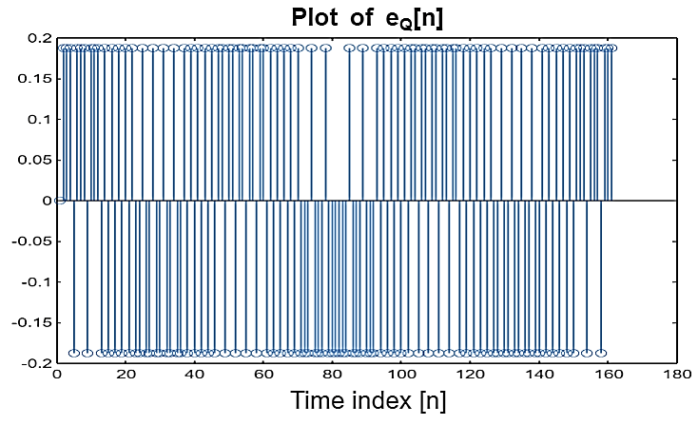

1. At the receiver, the task is to accumulate these received quantized error alphabets. This may be done by a first-order delayed feedback system as shown below:

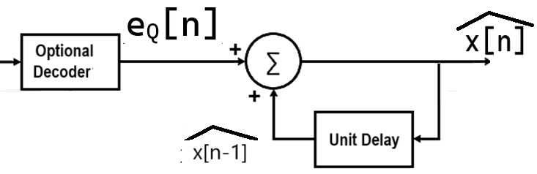

Where $\hat{x[n]}$ is the recovered signal obtained from $e_{Q}[n]$. $\hat{x[n]}$ may be expressed mathematically as follows:

$$\hat{x[n]}=\sum_{m=-∞}^{n}{e_{Q}[m]}=\hat{x\left[n-1\right]}+e_{Q}[n]$$

In MATLAB, this may be implemented in one line using **cumsum** command. SO, using cumsum, one obtains the following plot for $\hat{x[n]}$, when plotted against the true time scale:

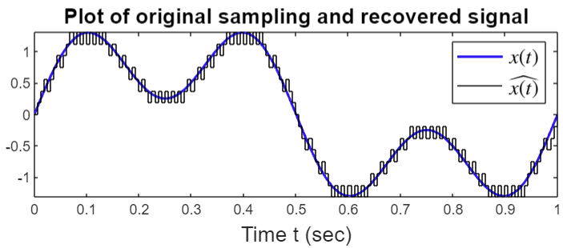

1. The next task is to use an appropriate lowpass filter to remove harmonics and other higher-order frequency components from $\hat{x[n]}$ to obtain a more smooth version of $\hat{x[n]}$, resembling more like the actual sampling signal $x(t)$.